**Assignment 2 18481A0478**

**Automatic Garage door opening system using ultra sonic sensor:**

Design Model:

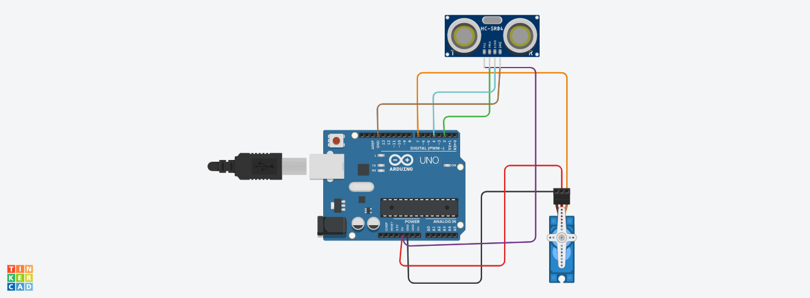

C++ code :

#include<Servo.h>

Servo myservo;

int trigpin=2;

int echopin=4;

void setup()

{

Serial.begin(9600);

myservo.attach(7);

pinMode(trigpin,OUTPUT);

pinMode(echopin,INPUT);

}

void loop()

{

digitalWrite(trigpin,HIGH);

delay(1000);

digitalWrite(trigpin,LOW);

float duration=pulseIn(echopin,HIGH);

float distance=duration*0.0343/2;

Serial.print("The distance is: ");

Serial.println(distance);

if(distance>80)

{

myservo.write(90);

Serial.println("The garage is opened");

delay(5000);

myservo.write(0);

Serial.println("The garage is closed");

}

else

{

myservo.write(0);

}

}